# Analysis of current system – From an Observation

## Information Systems Department Overview

The Information Systems (IS) department currently have approximately 20-30 employees. Covering network and user support, database administration, infrastructure support, system development, business analysis and IS functional support to the other areas of the business. The services provided by the IS department have significantly changed over the past couple of years; with the focus changing to managing and developing projects that offer business improvements, instead of just solving technical issues. It is therefore hoped that a new system will enhance the efficiency of the department further and help with the management of resources.

## Business Process

I have observed and recorded the IS department’s usage of the current system. The Activity Diagram (Fig.1) below highlights the workings of the current system; showing the business process behind it and how the system is used within the department. The diagram can also be used to help identify any potentially problematic parts of the system or areas of the process.

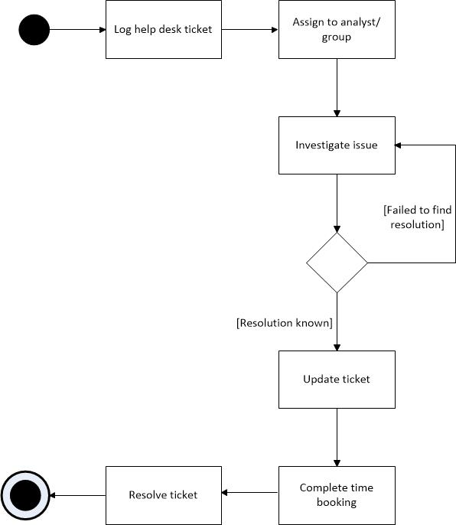

Fig 1. Activity Diagram of current system

## Current System

## Introduction into the system

Numatic International are currently using ‘SupportWorks ITHD’ application, created by Hornbill Systems; this is a high level ticketing and issue tracking system, designed for use in help desk and information technology (IT) environments. The system provides straightforward call management functionality to the helpdesk and assists with the management of projects and development to systems. The SupportWorks client is a desktop application, which uses a Microsoft SQL database backend.

Numatic has been using this system for approximately 5 years, although, it is a commercial off the shelf system, there have been varying degrees of customisations to the application to help it meet the changing needs of the department. Numatic now require a new system to replace the current one, this would help further meet the needs of the business.

Numatic are currently using SupportWorks for two main objectives; managing calls (tickets) on the helpdesk and tracking employee activities and resources, along with a number of other functions. These are investigated further below:

## Call Management

Calls (tickets) are difficult to manage in SupportWorks, as there is no concept of call classes. Therefore all calls are currently logged as incidents; with the call type of ‘helpdesk’. Meaning there is nothing that distinguishes between an incident and those calls that stay open indefinitely or for projects/ changes to the business.

Incidents are predominantly logged from telephone calls to the IS support desk (70% of the time) with the reminder calls being logged by emails sent directly to the IS helpdesk email. These incidents are then assigned to an analyst in the network support team, they are then investigated and fixed; these calls are normally resoled within a few days to a week. There are approximately between 5-20 incidents logged to the helpdesk every day. They are logged from users in every aspect of the business and are customer based in the fact that a particular user requires something to be fixed/ done.

Tickets are also logged by members of the IS team to track the development of systems and to manage projects within the department. This allows members of the project to be aware of how it is progressing, due to all updates regarding that particular project being contained in the same record.

The management of employees is also done through tickets, currently there are many calls open that are for tasks that occur on a regular basis or for general activities, such as daily backs up and network management. This allows employees to book time to tasks which may not be directly related to a specific call, such as a team meeting.

## Time Booking and Employee Management

The IS Manager uses SupportWorks to extensively track the time analysts spend working on calls and projects. Analysts are required to update calls with details of what was worked on, along with the time spent on that particular call. Time bookings can also be back dated to the previous week, so that the accurate time is recorded.

The reporting functionality is also used in conjunction with the time bookings, allowing weekly reports to be ran, showing the time booked per analyst or per call. Providing useful documentation for managers to review employee resources and to plan future resources. This feature however, does not provide the IS manager with the exact information he would like meaning members of staff in the admin team have to complete additional manual work to collect this information.

This is one of the most used features of the system used by Numatic, and the information is used to work out utilisation against projects and calls. With the aim of allowing more resources to be working on high level projects and urgent matters. The projects and admin team also find the time booking data helpful, time bookings from previous projects and calls help to make more precise and realistic estimates for future project planning.

Using SupportWorks as a method of booking time is an example where the system is used for a purpose which it was not originally intended for. Whilst the system allows time to be booked to particular calls, it was not developed as a time booking system, expecting staff to book all of their time to certain projects, calls and tasks worked on during a particular day.

## Usage Statistics

Since Supportworks has been used at Numatic there have been over 12,000 calls logged; of these calls there are currently about 450+ open calls. Many of these calls are permanently open and contain tasks to be completed daily, such as the ‘F0003191 – Undertaking of daily back ups’.

Below shows a chart (Fig. 2) analysing all the tickets that are currently open in the current helpdesk for each department or sub department, it also shows the type of call that has been logged. From this table it is clear that there are very few incidents (problems); 8% of all open calls. It also shows there are many more changes or management type of calls, which are linked to projects being undertaken within the department; 33.7% are calls with the class ‘change’. It also shows the large quantity of tickets that are open in this system. In the average helpdesk there are approximately 160 calls open, Numatic have about 3 times that figure with 486 calls open.

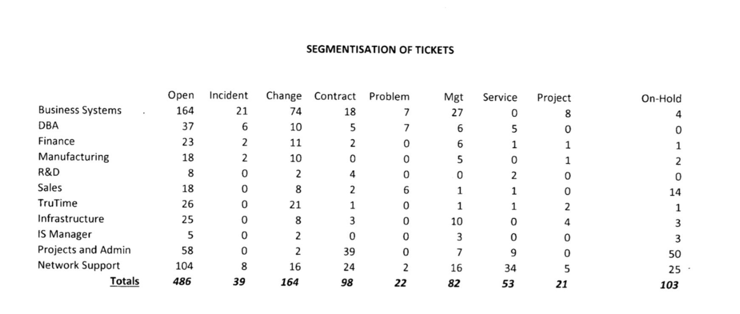

Fig 2. Segmentation of tickets

## Problems of current system

There are many problems with the current system, due to the system not being tailored to the needs of the department and also stemming from the way the system is used.

A lack of staff training, has resulted in many calls not being logged; due to analysts not having enough time or deeming the problem to not be a big enough issue to be logged; such as resetting a password or another ‘quick fix’ solution. A lack of training has also meant that some features of the system are not used at all; workflows are not used and are instead users just reassign the call to another analysts. Some analysts do not use SupportWorks as often as required; leading to, many calls not be accepted and calls not being kept up to date. This means that often managers will have to chase up analysts for updates, instead of getting the required information directly from the call, thus wasting time unnecessarily.

These problems mean that tasks are sometimes forgotten or missed and that it is difficult for management to fully investigate any common repeating issues. It also makes booking time problematic and often leads to analysts booking time to a general call, such as ‘Helpdesk – quick fixes’.

Many of the issues, however, are not down to the users or a lack of training and instead is due to the design of the system. Whilst undertaking the observation and investigating the system, I was made aware of some particular issues and problems that the users face in the use of the system. These issues have been then further analysed and investigated, I have included some examples of these issues, with screenshots below:

The call class is not used correctly, as every call is a ‘helpdesk’ type. Even though this is not the case as many of the calls are project or development related tasks. Ideally different calls would have an appropriate class for the different type of calls, such as, incident, change, problem and management. This would allow analysts to easily see what type of calls they had open and possibly filter down calls on the call class.

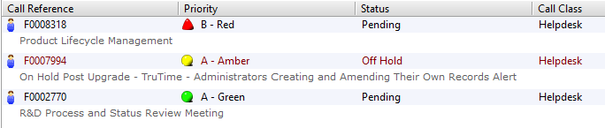

For example the ‘Product Lifecycle Management – F0008318’ call has been open since the 03/08/2012 and is used to manage the PLM project and collect time booking information. This call would not be classed as ‘helpdesk’ within the IS department, yet it is not given a more relevant call class.

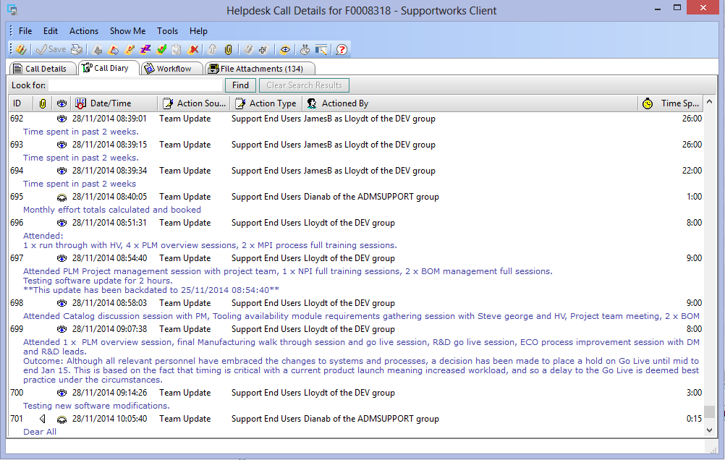

The larger projects/ tasks are often hard to keep track of in the system, due to large quantities of updates being done mainly for time booking purposes as opposed to informative updates. These updates are not helpful and just make it harder to find updates due to the large number of time bookings (Oracle R12 and BI Upgrade – F0012335):

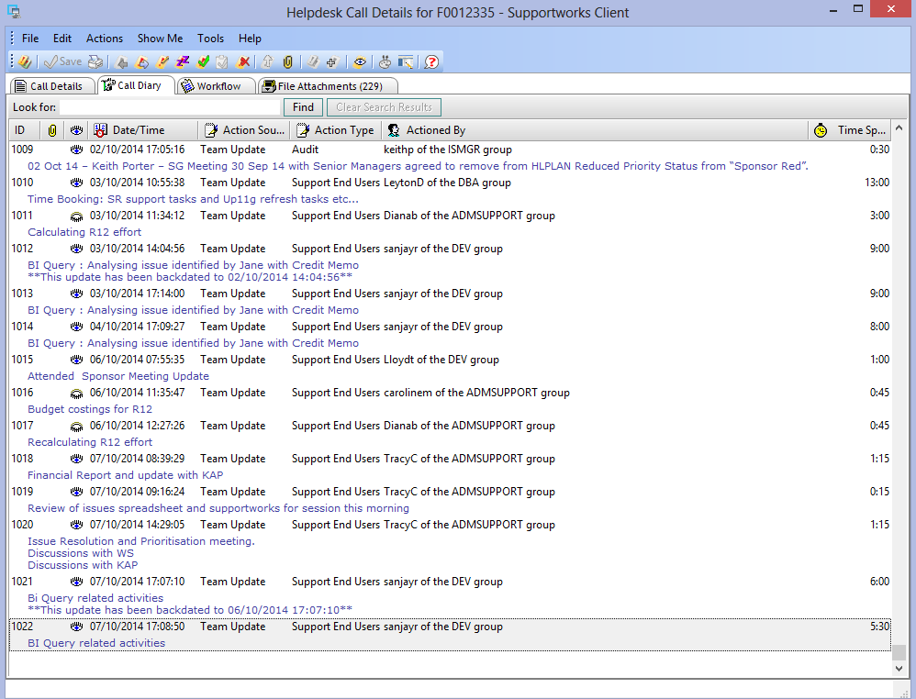

Post R12 Post Implementation User Issues – F0012655, which again shows many time booking updates. As the update text field is compulsory the update is often not informative and pointless:

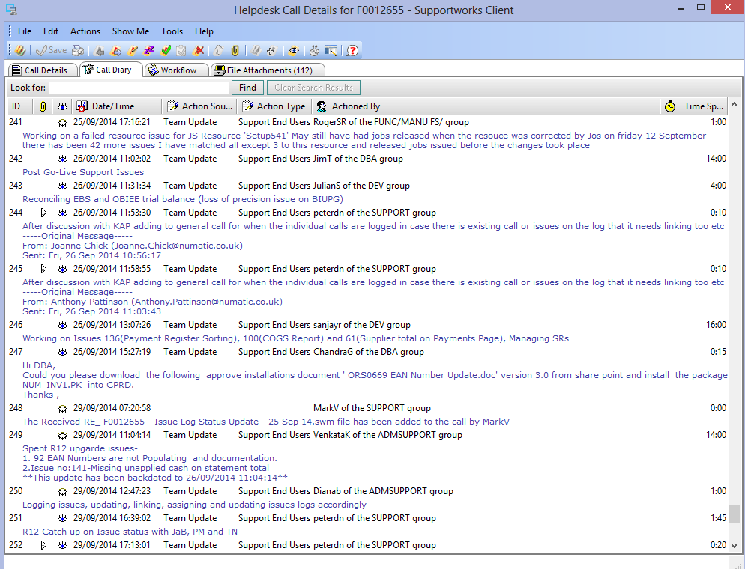

As all calls are helpdesk calls, the customer details section is required to be filled in; even though this is not applicable to many of the project related calls. As a project or upgrade of systems will not have a direct customer, it is benefiting the whole company.

Requiring users of the system to enter details such as, the customer information, will often hinder the user from logging the call. Not knowing who to put in the customer fields, does not encourage employees to log calls, leading to calls potentially not being logged or delaying the time to log a call as the employee may want to seek clarity in the customer information.

The Oracle R12 and BI Upgrade – F0012335 call is a database upgrade project and therefore has no direct customer. In this case the customer was added in as the IS Projects Manager:

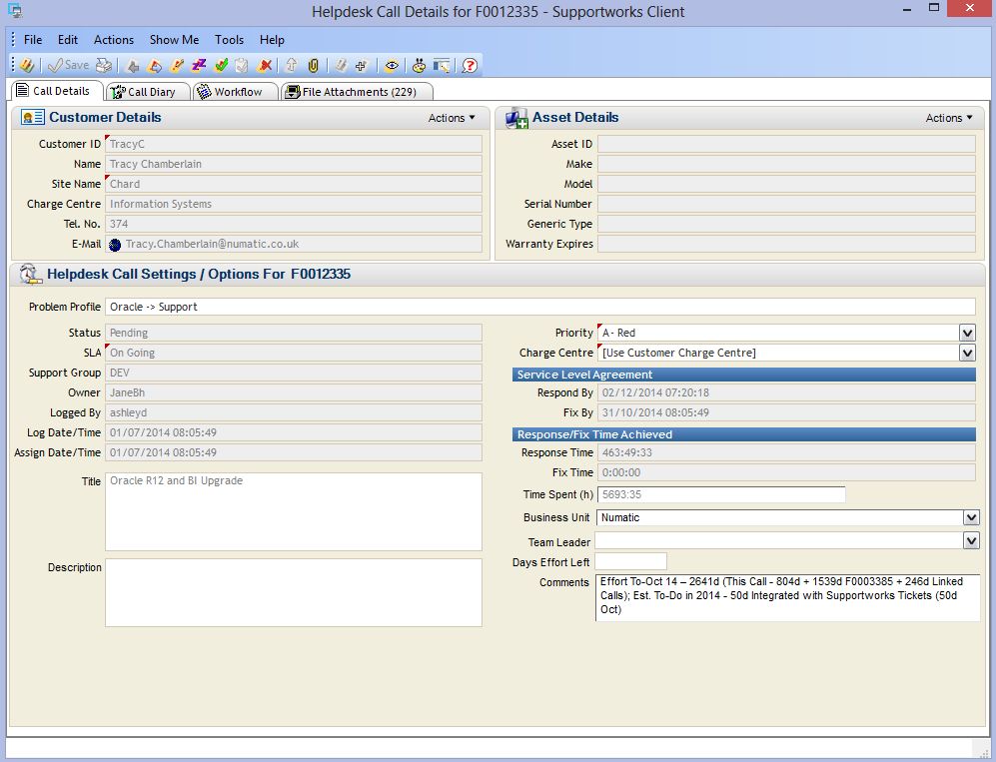

There are some calls that are indefinitely open to keep track of IS employees, for training and other various tasks. Such as the ‘IS Networking Management – F0004865’ call, used for booking time to attending meetings and training and carrying out tasks which do not fit into a particular call. These tasks are often ones that happen on a frequent basis, or are to with the general management of the team.

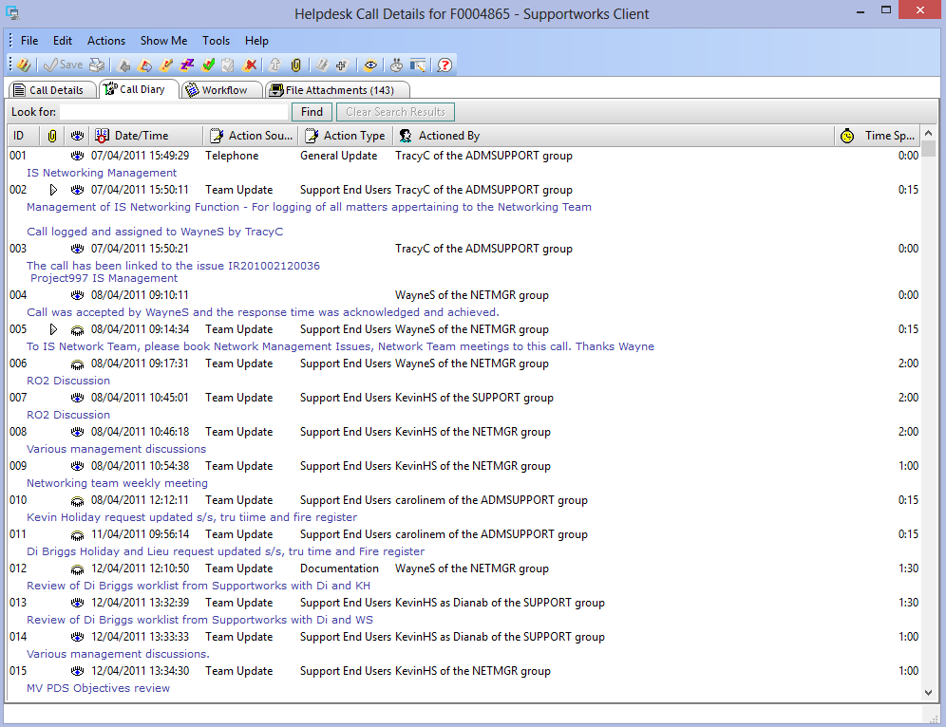

‘Helpdesk quick fixes – F0006127’, this call is open indefinatly and allows analysts to book time for general tasks, not related to one specific to a call. However this call often gets a high level of time bookings; this is mainly down to the fact it is a lot easier to book to this call, rather than creating a new call. Whilst many calls logged in this call are classed as quick fixes, logging them here means we have lost sight of two things; recurrent issues on behalf of a user, and volumes of resolved and pending calls for a department. This makes reporting on calls more complex and requires members of the admin team to read through the call to ensure none have been missed.

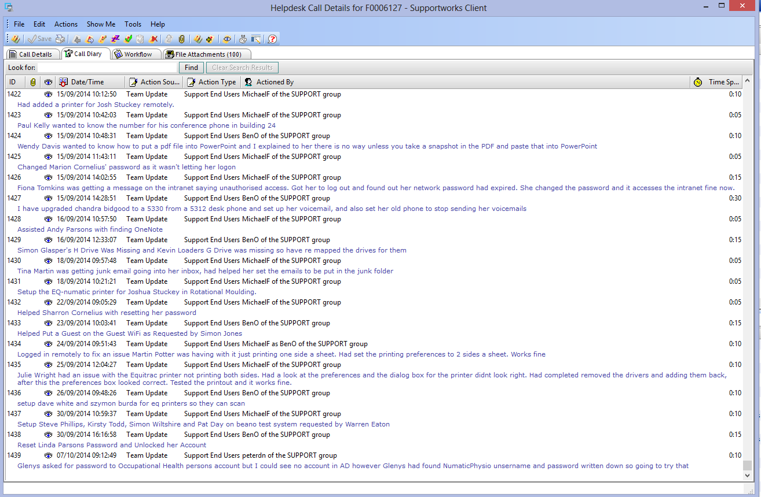



There are some calls that are open for daily tasks; allowing time to be booked for an activity which occurs on a frequent basis. Therefore calls become very large with a high quantity of updates, just to book time for completing these tasks. In a standard helpdesk system these type of tasks would not be logged in the system, however, this has been done at Numatic to allow for time bookings to be made against it. Such as the ‘Undertaking Periodic Back Up – F0003191’ call:

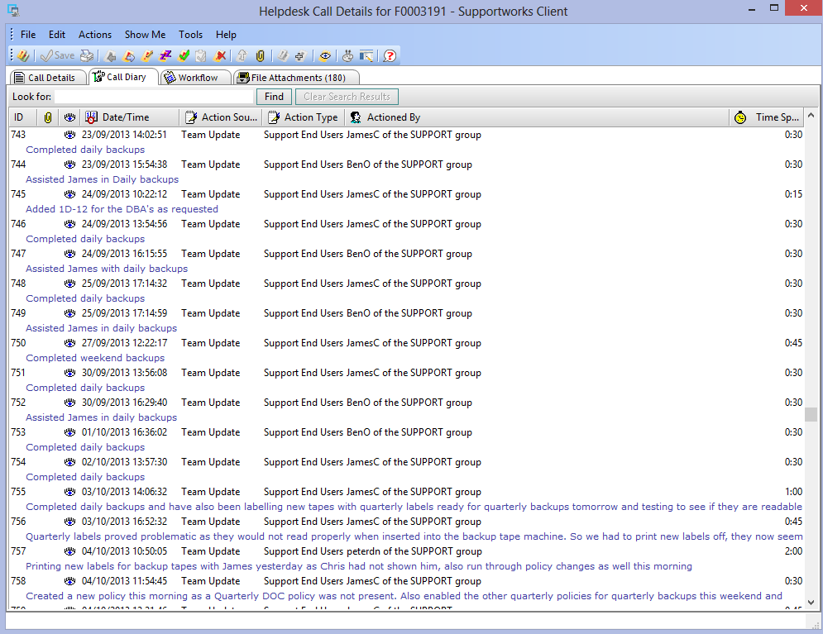

The ‘Quest TOAD Support – F0000037’ call, has been open since 2009 and is used to manage the licencing of Toad software and the management of Toad support for users. This is another example of a call that is open indefinitely and one that is primarily used once a year, when the licences require renewal.

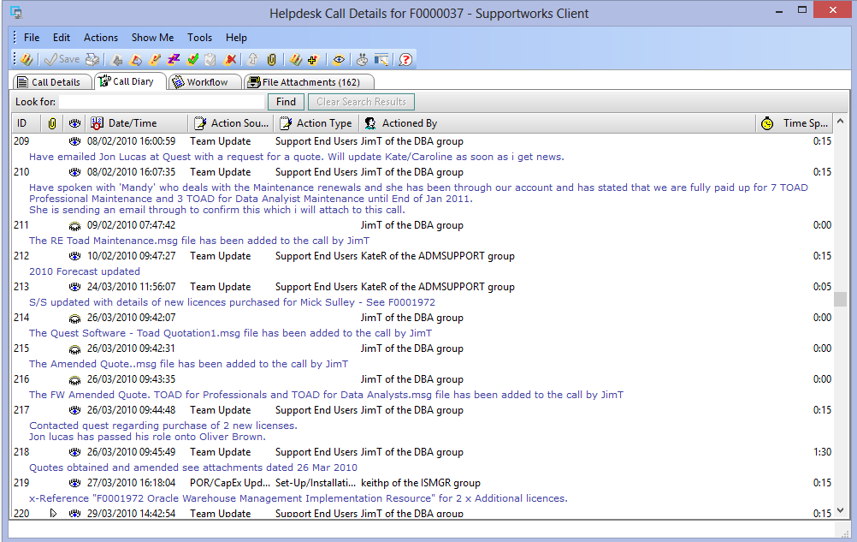

Calls are often related to an underlying issue or the overall management of devices or software, in these situations, analysts are required to link specific calls to the relevant issue. This process is often time consuming for employees and frequently problematic as the task of linking and unlinking issues is too complex. This creates annoyance and disincentives the end users to link calls to issues.

Having a large amount of issues and long issue reference numbers (issue ID), means that it is hard to find the correct issue to link the call to, it is often hard to know if there is a relevant issue without having to look through the large list of issues. Here is a list of some of the issues that a call can be linked to:

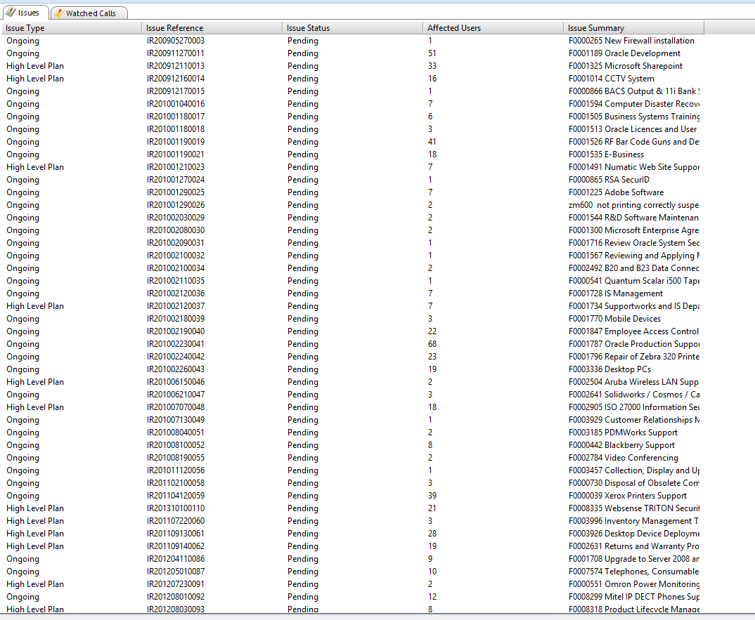

More problems are encountered when an employee tries to resolve a call that is linked to an issue. As calls cannot be resolved whilst linked to an issue, it means that users have to unlink the call from the issue, resolve the call and then link the call back to the issue again. This often annoys the end users of the system, and they get this error message after trying to resolve the call.

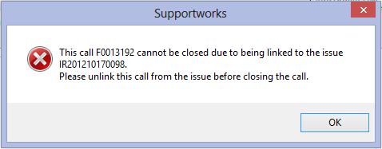

This task is made difficult as a simple requirement such as copy and paste is not available from the screen, which would allow users to be advised which calls are linked. As the codes are long it means that this task becomes a manual one, having to use pen and paper to write down the issue code and the call ID, in order to complete the process. This task is frustrating for users and provides no functionality to analysts; only assisting management with reporting of calls and issues. Therefore this does not motivate users to link calls to issues and is seen as a redundant task, which creates additional work.

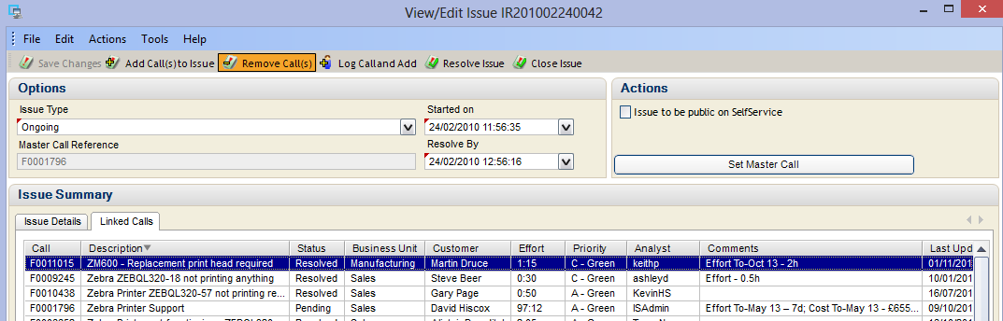

Further complications can arise from this process, by selecting ‘Resolve Issue’ instead of ‘Remove Call(s)’ the issue will be resolved. Leaving the user who resolved the issue, with all the linked calls in their own queue, which at times can be over 100 calls.

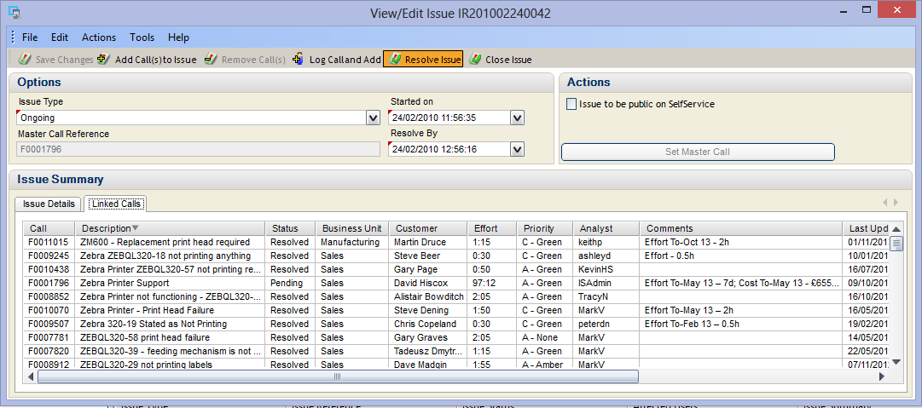

The time taken to go through every call and examine if the call needs to be re-linked and whether or not it needs to be re-assigned to another user is very high, again causing unnecessary time wasting. This often means that other employees need to get involved to help clean up the calls, such as the admin team. Mitigating this problem is also hard, with an employee accidentally resolving an issue twice within the period of a month; training users can minimise this potential problem, however, will not solve this it. This is an example of where the system’s complexity negativity impacts the use of the system and can create additional manual work.

There are also potential problems associated to time bookings; leading to inaccuracies on time booking reports. As users cannot delete an update it means that if a user accidentally books time to the wrong call then they cannot delete the update or time booked, they can only edit the update text. This often means that a user will accidently book something to wrong call and then once they have realised go back and edit the text to say booked in error. This means that when the report of time booked for the call or analyst are run, the report will be inaccurate.

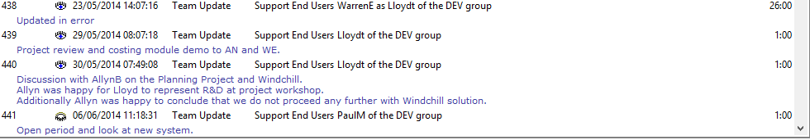

## Overall Conclusions

From this analysis of the current system it is clear to see that whilst the system is being used to achieve many of the requirements of the IS Manager, it is not the ideal system for the job. As it has not been designed specifically for Numatic as an end user, many of the features are not used as originally intended or modified in a way to allow Numatic to use it in a way they want.

Overall many of the problems with the system steam from the fact that the system is an off the shelf generic helpdesk system, that was purchased due to price and unrealistic ideals. This has now lead to the large majority of the staff within the IS department disliking the system and find using it more of a hindrance than helpful.

This suggests that Numatic requires a new system that can be specifically customised to Numatic’s needs and business, such as better time management/booking features. This will allow the IS department to be managed more efficiently and will reduce the amount of problems that are currently seen in the system.

The new system will require emphasis on the time booking feature as well as call management. These requirements will be further investigated in the requirement elicitation phase.

## Potential Problems with New system

Creating a new system, will allow most of the problems investigated to be minimised as the new system, will be based upon the user requirements and tailored to Numatic. However there is still the potential that there will be some problems, this is because of the way the system is used. To try and combat these issues, there will be a strong focus on user training; with user guides and a help section to the system. This will inform users on how the system should be used correctly.